SUBMITTED BY

TEAM ID: NM2023TMID3087

TEAM MEMBERS

DEVIPRIYA.K : (A5F6C31EA000E3286E646A3B29D1786C)

PAVITHRA.M : ( 1673698CF818BB8935E45B66302EA893)

KIRUTHIKA.D: ( 546D5A5F13C513292294D34550E4665D)

RUBHAVANI.V: (58709F646F1E88DAEB84E13AB9DD5375)



**DEPARTMENT OF ELECTRONICS**

**L.R.G GOVRNMENT ARTS COLLEGE FOR WOMEN**

**TIRUPUR- 641604**

DATE: 13 OCT 2023

13 OCTOBAR 2023

**A DATA DRIVEN EXPLORATION OF APPLE'S IPHONE IMPACT IN INDIA**

**1.PURPOSE**

***1.1 Overview***

Smartphone use has changed the world. Smartphones have improved communication, connected people, and revolutionized numerous businesses. Markets around the world are being captured by iPhones. In terms of smartphone usage, India has the fastest economic growth. In comparison to other android systems, the iPhone communicates quickly with networks. Compared to android mobiles, iPhones have the best camera and video-making capabilities.

***1.2 Purpose***

Apple's iPhone introduced multi-touch technology for the first time. The value of Apple IPhone makes it the world's most valuable publicly traded company. IPhone is the smartphone made by apple that combines a computer,IPod,IWatch into a device with a touchscreen interface.

**2.PROBLEM DEFINITION & DESIGN THINKING**

**2.1 Empathy map**

The empathy map in think different demonstrates that Apple's iPhone has a strong market penetration in India.

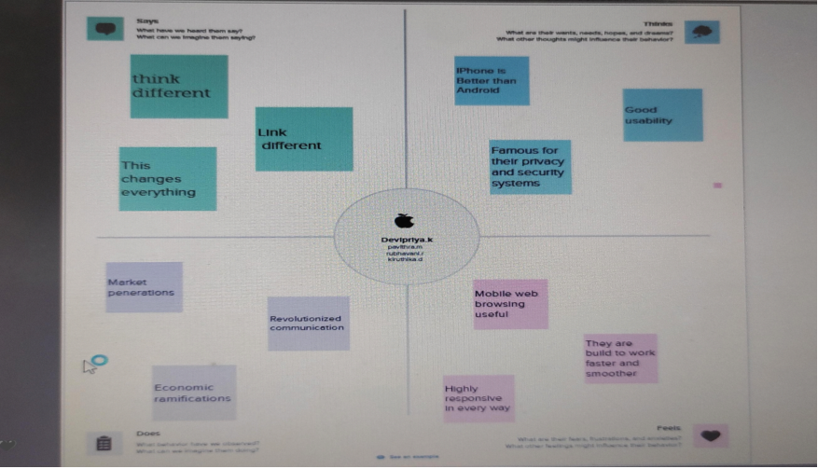

**2.2 Brainstrom map**

For problem defining and solving, we use a brainstorming map to explore apple's iPhone impact in India.

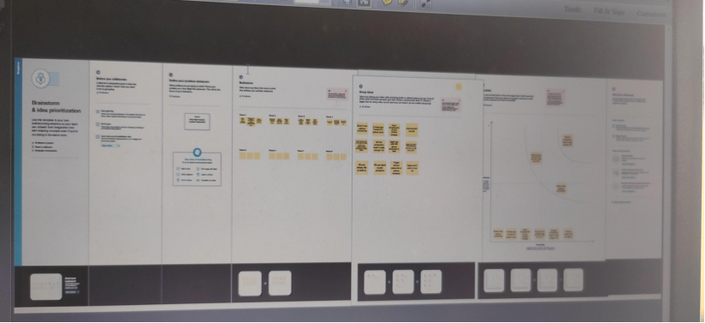

**3. RESULT**

This project was designed to help you determine the market value of Apple's iPhones in India, based on data driven analysis. This report includes KPI for brand and price, model specifications, a bar chart showing battery types, a tree map showing brand prices, a bubble chart showing model-specific iPhone share, a line chart showing annual revenue, a text table showing global market share, and a map showing global market share.

The following chart explains the different apple brands and their sale price.

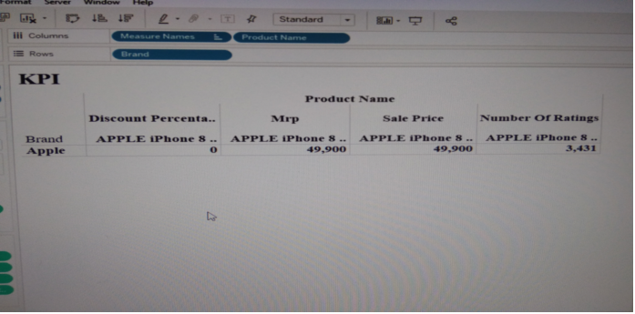

The following visualization chart represents specifications of different apple brands like APPLE IPHONE 11,APPLE IPHONE 12, APPLE IPHONE 12 MINI and many more types of brands. In the all models front camera is 12 MP and Rear camera differs all the models.

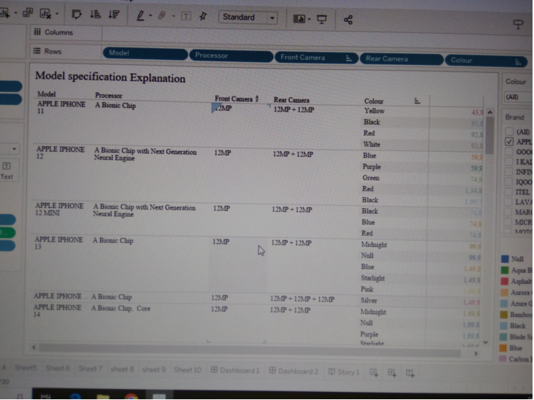

Next chart describes various type of batteries Lithium, Lithium Ion, Lithium Polymer battery. Most of the iphones used a Lithium battery type.

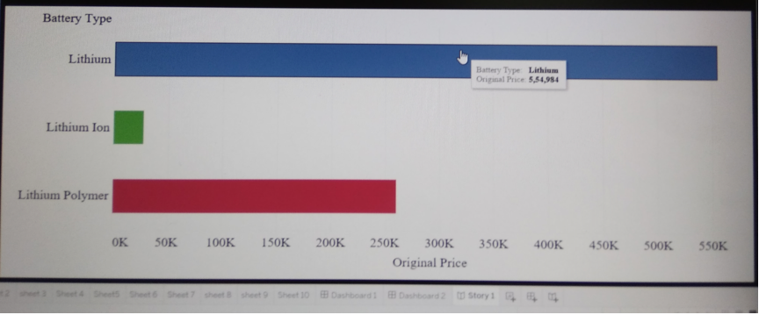

This chart compare the price of different Apple phones.

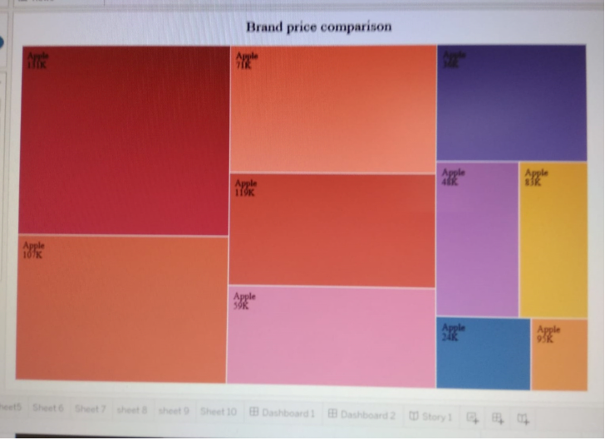

In this type of bubble chart, IPhone 13 and IPhone 14 and pro max share value is the highest range of the market the value of 0.1700. The minimum market share value Apple IPhone 13 the value 0.0400.

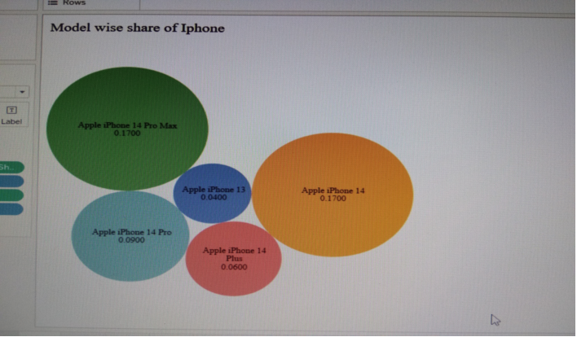

The following chart explains the countrywise best selling smartphone.

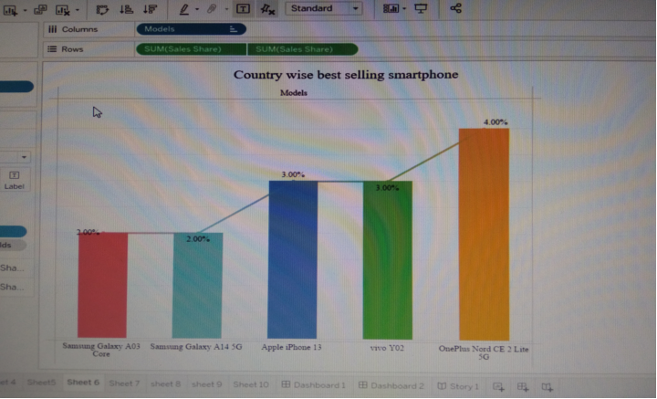

The following dough nut chart visualize the Quarterly share of the smartphone models.

Xiaomi brand’s percentage of share is 12.34%. Samsung brand’s percentage of share is 29.05%.

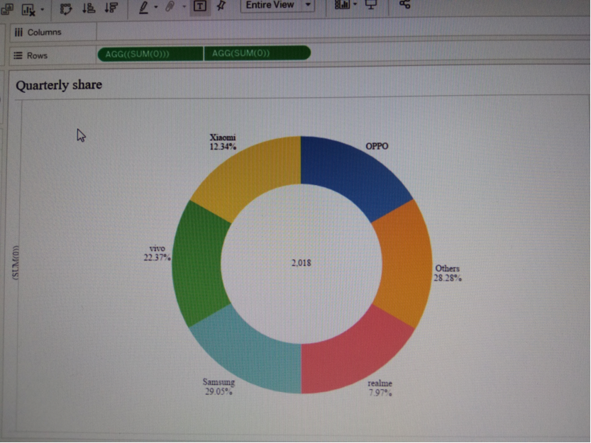

Following map contains Annual revenue starts the year of 2006 to 2022.

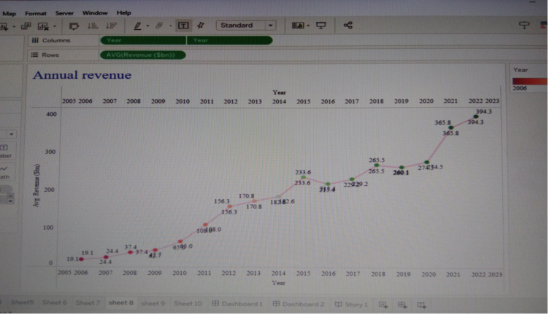

It contains Yearly Key Performance Indicators , which include customer satisfaction and revenue.

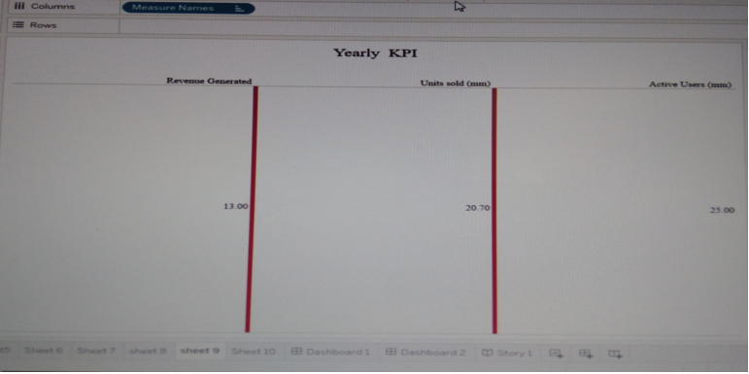

This chart shows the global market share country wise in India.

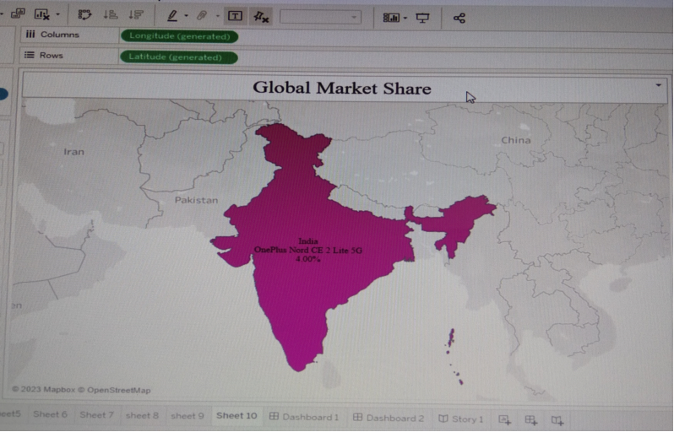

**4. ADVANTAGES & DISADVANTAGES**

***4.1 Advantages***

* User friendly Interface:

The touch screen interface is easy to use ,and the IPhones smooth operating systems is simple to learn and use

* High Quality Display:

The IPhone's Retina display is the one of the best in the market .The high Quality display is perfect for tv shows, movies and games

* Advanced Camera:

IPhone device has the best camera in the worlds marketing campared to other android smartphones.

* They have been known to produce stunning images and videos of the highest quality.

***4.2 Disadvantages***

* Cost:

The iphone is one of the most expensive smartphones on the market. High and models can cost over $1000,which makes it a luxury items for many people

* Non removable Battery:

The iphones batteries or non-removable,which means that users can't replace them.

* Limited customization:

One of the disadvantages of the Iphone is that it has limited customization options.

**5.APPLICATIONS**

App store: App store has proved to be safe and trusted place to discover and download apps.

Apple store : Read reviews, compare customer ratings, see screenshots and learn more.

Apple developer :Download apps by Apple, including apple partner media review, Tes t Flight, Apple Developer and more.

Apple Maps :Apple maps have reached the point where its just as good, if not better than google Maps.

Lapse: Disposable camera

**6.CONCLUSION**

It is apparent that the IPhone was,and still,a remarkable invention oftechnological advancement. The IPhone provided a new way of mobile phone communication and usability. Apple IPhone is the better quality and better security. Innovation and technological advancements. IPhone is popular and in High Demand.

**7.FUTURE SCOPE**

Operating system: The next version of IPhone's operating system will improved.

Software: Deliver some of the best Software experience

Marketting: World becomes a full of IPhone usage in the future

Battery : IPhone battery capacity must be increased.